Department of Housing and Urban-Rural Development of Jiangsu Province

Announcement

[**2017**] No. **36**

Announcement of the Provincial Department of Housing and Urban-Rural Development on   
matters related to the disqualification of jiangsu provincial supervisors for supervising engineers in Jiangsu Province

In order to thoroughly implement the reform requirements of "decentralization and management of services", further strengthen the management of supervision personnel, standardize the on-site behavior of supervision personnel, improve the service level of supervision work, and ensure the quality and safety of the project, we are now taking the qualifications of supervision engineers in Jiangsu Province and supervisors in Jiangsu Province The announcement of related matters after the elimination is as follows:

I. According to the requirements of the "Notice of the Provincial Human Resources and Social Security Department on Canceling the Self-Established Occupational Qualifications of Our Province" (Su Ren Shefa [**2015**] No. **344**), the "Jiangsu Provincial Supervision Engineer" who has been cancelled And "Jiangsu Province Supervisor" qualifications, in our province housing construction

Bidding for municipal infrastructure projects is no longer used as a qualification requirement and scoring factor. '

Second, support institutions of higher learning, social training institutions, and qualified supervision enterprises in carrying out professional training for professional supervision engineers, supervisors, and other posts, and implement "who trains, who issues certificates, and who is responsible"; encourage and support relevant industry associations to compile training standards, training materials, and carry out business training according to the needs of the industry.

Third, the unit carrying out supervision business training may, on the basis of the "Construction Project Supervision Specification" **(GB/T50319-2013),** analyze the relevant laws and regulations and standards for construction project supervision, project supervision and project management theories, methods and project supervision classic cases The main content is systematic and focused business training.

Fourth, the Provincial Department of Housing and Urban-Rural Development will establish a database of professional training units and training information for supervisors, and training units and personnel participating in the training may voluntarily enter the information on units, individuals , and training results into the database.

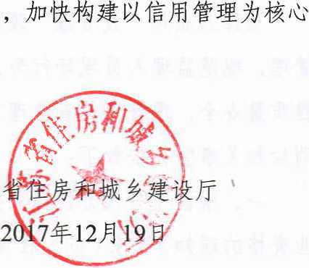Fifth, the competent administrative departments for construction at all levels should strengthen supervision and inspection of the ability of supervisors to perform contracts and the performance of their performance, and change the new market supervision mechanism of supervision and management thinking.

Jiangsu

(This piece is publicly available ；

Office of the Department of Housing and Urban-Rural Development of Jiangsu Province

Issued on 19 December 2017